1 Stochastic pix2vid: A new spatiotemporal deep learning

2 method for image-to-video synthesis in geologic CO2

3 storage prediction

4 **Misael M. Morales**1*∗*, **Carlos Torres-Verdin**1*,*2, and **Michael J. Pyrcz**1*,*2

5 1. Hildebrand Department of Petroleum and Geosystems Engineering, The University of Texas at Austin

6 2. Jackson School of Geosciences, The University of Texas at Austin

7 *Corresponding author; email: [misaelmorales@utexas.edu](mailto:misaelmorales@utexas.edu)

**Abstract**

Numerical simulation of multiphase flow in porous media is an important step in understanding the dynamic

behavior of geologic CO2 storage (GCS). Scaling up GCS requires fast and accurate high-resolution modeling

of the storage reservoir pressure and saturation plume migration; however, such modeling is challenging due

to the high computational costs of traditional physics-based simulations. Deep learning models trained with

numerical simulation data can provide a fast and reliable alternative to expensive physics-based numerical

simulations. We propose a Stochastic pix2vid neural network architecture for solving multiphase fluid flow

problems with superior speed, accuracy, and efficiency. The Stochastic pix2vid model is designed based on

the principles of computer vision and video synthesis and is able to generate dynamic spatiotemporal predic-

tions of fluid flow from static reservoir models, closely mimicking the performance of traditional numerical

simulation. We apply the Stochastic pix2vid model to a highly-complex CO2-water multiphase problem with

a wide range of reservoir models in terms of porosity and permeability heterogeneity, facies distribution, and

njection configurations. The Stochastic pix2vid method is first-of-its-kind in static-to-dynamic prediction

of reservoir behavior, where a single static input is mapped to its dynamic response. The Stochastic pix2vid

method provides superior performance in highly heterogeneous geologic formations and complex estimation

such as CO2 saturation and pressure buildup plume determination. The trained model can serve as a general-

purpose, static-to-dynamic (image-to-video) alternative to traditional numerical reservoir simulation of 2D

CO2 injection problems with up to 6,500*×* speedup compared to traditional numerical simulation.

**Keywords:** Image-to-video synthesis, Spatiotemporal prediction, Convolutional neural network, Recur-

rent neural network, Proxy model

**1 Introduction**

Geologic CO2 sequestration (GCS) has emerged as a potential technology solution to reduce anthropogenic

greenhouse gas emissions to the atmosphere [1–3], and has become increasingly popular worldwide due to

the need to meet international climate protection agreements [4–6]. Modeling injected CO2 movement in the

subsurface over and beyond the life of the project is a critical component to support optimum GCS project

decision making for safe and secure CO2 sequestration. A schematic of typical GCS operations is shown in

Figure 1, including storage in depleted oil and gas reservoir and deep saline formations, and CO2 enhanced

oil and coalbed methane recovery [7–9]. However, there are several technical challenges associated with

the subsurface modeling to support GCS operations. To accurately forecast and monitor subsurface

multiphase flow, physics-based high-fidelity numerical simulations are required. These numerical simulations

are computationally intensive and time-consuming since they require iterative solutions of nonlinear systems

of equations applied over large volumes of the subsurface at sufficient resolution to represent heterogeneity

[10–12]. Also, due to the large degree of uncertainty in subsurface data, and the spatial distribution of

the properties of heterogeneous porous media between the sparsely sampled data, GCS operations require

a robust probabilistic-based uncertainty assessment for improved engineering decision-making [13–15]. In

order to capture the fine-scale multiphase flow behavior given an uncertain spatial distribution of subsurface

properties, a large number of numerical simulations are required, leading to very high computational costs and delayed feedback unable to support timely decision making[16, 17].

To overcome this, machine learning techniques have emerged as candidate proxy models due to their

ability to perform dimensionality reduction for efficient problem parameterization and model complicated systems to calculate fast pre-

dictions of subsurface flow and transport behavior for real-time feedback on the impact of geological and

engineering controls on CO2 behavior in the subsurface over time [18–20]. Dimensionality reduction tech-

niques are supervised or unsupervised machine learning methods that compress (or encode) the data, *X*, into

a lower-dimensional latent feature representation, *z*, and decompress (or decode) the latent representation

either: (1) back to the original data space, *X*ˆ (unsupervised, AutoEncoder), or (2) to a new response feature

space, *y* (supervised, Encoder-Decoder) [21, 22], as shown in Figure 2. The recent advance-

ments in deep learning algorithms, and in computing architecture and power, enable GPU-enabled neural

network models that have accelerated the fields of forward and inverse modeling [23, 24]. Classical statistical

modeling methods are often hindered by the size of the models and their conditioning to big data, i.e., that

is data with volume, velocity, variety, value, and veracity [25, 26]. By analyzing big data sets, machine

earning techniques can uncover complex patterns and relationships in lower-dimensional, latent feature rep-

resentations that may not be discernible through traditional statistical and geostatistical methods [27–29].

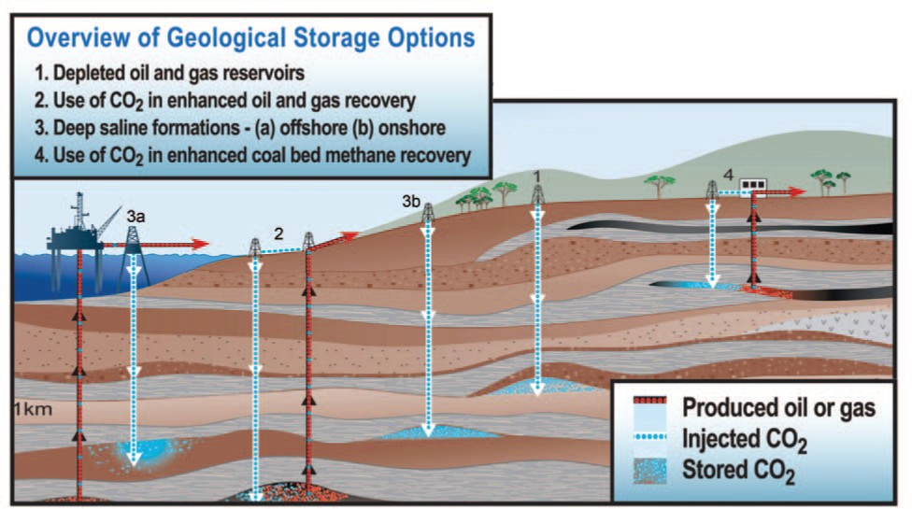

**Figure 1:** Types of geologic CO2 storage operations and the geologic formations that can be used for sequestration. *Modified from the Carbon Dioxide Cooperative Research Center (CO2CRC),* [*http://www.co2crc.com.au/about/co2crc*](http://www.co2crc.com.au/about/co2crc)

When combined with a latent space modeling framework, machine learning approaches efficiently and

accurately exploit hidden features in the data, removing redundancies or noise [CITATION], and decreasing the order of

the problem significantly [30, 31].

Supervised machine learning approaches applied to the subsurface are divided into two main categories, namely

purely data-driven models or physics-informed models. Data-driven proxy models, or data mapping op-

erators, are neural network architectures trained with labeled data that produce a mapping from input

predictor features to output response features [32, 33]. On the other hand, the training process to match

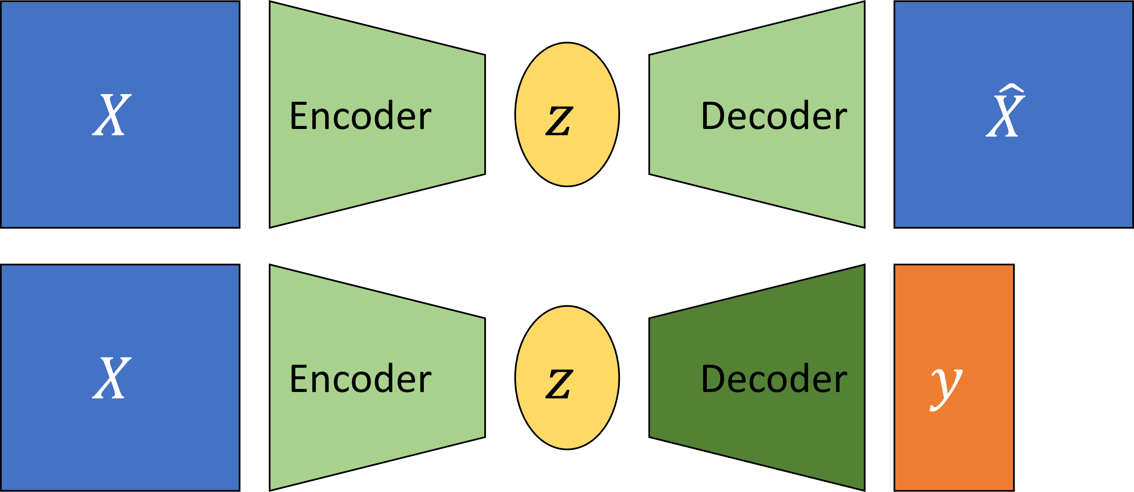

**Figure 2:** Dimensionality reduction model structure. Unsupervised AutoEncoder structure (top), and supervised Encoder-Decoder structure (bottom).

training data for PINNs is regularized with the minimization of the (physical) loss from the residual of the

governing partial differential equations (PDEs) along with the losses associated with the initial and boundary

conditions [34, 35]. However, other variants of PINNs such as physics-guided or physics-constrained neural

networks where the PDE loss is not embedded in the training step, instead the models have specific architectures or

parameters to mimic the physics in the system have proven useful for subsurface energy resource engineer-

ing applications [36–38]. One disadvantage of machine learning techniques is that they require significant

amounts of training data, but once trained these prediction models

beyond which they have been specifically trained [39, 40]

. For both data-driven

and physics-informed approaches, typically, spatial relationships are modeled through convolutional neural

networks (CNNs) [41, 42] and the temporal relationships through recurrent neural networks (RNNs) [43, 44],

but recent advancements in transformer-based architectures improve performance compared to the CNN and

RNN methods for spatial and temporal latent feature representations [45–47]. In general, efficient compres-

sion of the input features into a representative latent space is proven as an effective approach for spatial and

temporal parameterization of the forward or inverse problem.

A number of machine learning-based proxy models have been developed to estimate the

reservoir behavior in subsurface energy resource applications. Most techniques rely on the concept of image

translation, or pix2pix, where a target image(s) is predicted from an input image(s) [48–51], as shown in

Figure 3. Maldonado-Cruz and Pyrcz [52] develop a convolutional U-Net model to predict pressure and

saturation states given an uncertain geologic realization. This work is an example of image-to-image static

forecasting, where the time state is given as an input, and the proxy model will predict a single response

state of pressure and saturation at the given time. Wen et al. [53] develop a Fourier Neural Operator (FNO)

architecture to predict image-to-image response states of pressure and saturation from an uncertain geologic

realization and is further extended for multi-scale and nested domains [54]. These methods are based on

a pix2pix, or image-to-image prediction, where a specific timestep is used as an input feature to predict the

relationship between the geologic model and the reservoir response at that specific timestep. This implies

that pix2pix or image-to-image methods are formulated as an even-determined or sometimes over-determined

estimation problem, where the number of input features is equal to or greater than the number of output

features. Moreover, numerous other proxy models have been developed for subsurface applications using

more complex architectures such as generative adversarial networks (GANs) [55] and transformers [56, 57].

Despite showing consistent results and significant speedups compared to traditional numerical simulation,

pix2pix models do not capture the spatiotemporal relationships and dynamic response of the subsurface

system.

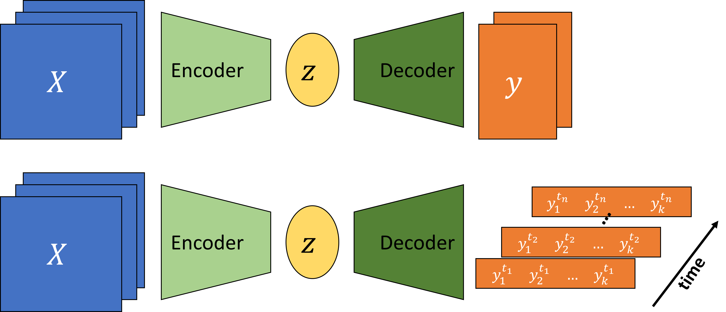

**Figure 3:** Image-to-image (pix2pix) (top) and image-to-timeseries Encoder-Decoder (bottom) structures.

Moving beyond image-to-image predictions, Kim and Durlofsky [58] develop a convolutional-recurrent

proxy for pix2time, or image-to-timeseries, forecasting and discuss its advantages for closed-loop reservoir

management under geologic uncertainty. This method moves beyond the image-to-image forecasting and

exploits a spatiotemporal latent space in an encoder-recurrent neural network architecture to obtain well flow

rates and pressures over time from a static geologic realization. The image-to-series formulation can still be

an even- or over-determined estimation problem, where we have equal or more inputs than outputs, as shown

in Figure 3. Furthermore, Tang et al. [59, 60] and Jiang and Durlofsky [17] develop a recurrent residual U-net

(R-U-net) proxy for the prediction of dynamic pressure- and saturation-over-time from uncertain geologic

realizations using an encoder-recurrent-decoder architecture. These methods aim to obtain dynamic response

states over time from a single static image. This type of proxy model is formulated to resolve the more complex

under-determined estimation problem (compared to even- or over-determined), where the number of input

features is a fraction of the number of output features. However, the recurrent R-U-net proxy is limited

by the fact that only the latent space receives spatiotemporal processing, while the model reconstruction

is done via time-distributed deconvolutions, treating time as an additional “spatial” dimension, and not

fully exploiting the spatiotemporal relations in the data and latent space as an image-to-video forecasting

formulation.

The problem of image-to-video forecasting, also known as video synthesis, has been approached previ-

ously by researchers in the field of computer vision [61–65]. Iliadis et al. [66] are one of the first to develop a

deep learning-based framework for video compressive sensing to reconstruct a video sequence from a single

image using a deep fully-connected neural network, or artificial neural network (ANN). Despite

excellent accuracy in the video predictions, this method is still limited by time-distributed fully-connected

layers in the encoder and decoder portions of the network, thus not exploiting the spatiotemporal rela-

122 tionships in the data. Xu and Ren [67] develop a three-part encoder-recurrent-decoder network for video

reconstruction from the estimated motion fields of the encoded frames. The implementation is similar to that

of [17, 59, 60] in that it applies a recurrent update in the latent space but relies on time-distributed deconvo-

lutions for the video frames reconstruction to exploit spatiotemporal relationships in the data. Dorkenwald

et al. [68] develop a conditional invertible neural network (cINN) as a bijective mapping between image and

video domains using a dynamic latent representation. The cINN architecture allows for video-to-image

and image-to-video predictions, demonstrating the generation of video frames from a static input image.

Finally, Holynski et al. [69] implemented the idea of Eulerian motion fields to define the moving portions

of the image to accurately reconstruct a series of video frames from a static image

using a spatiotemporal latent space parameterization. These advancements in the field of computer vision

and video compressed sensing are the foundation for our image-to-video proxy model.

We propose a novel image-to-video spatiotemporal proxy model, Stochastic pix2vid, for the pre-

diction of dynamic reservoir behavior over time from a subsurface uncertainty model, suite of static geologic realizations. Our model exploits the spatial and temporal structures in latent space to

dynamically reconstruct the time-dependent pressure and multiphase saturation states from a static geologic realization.

The encoder portion of the network receives as inputs the static geologic realizations with multiple features includingporosity, permeability, and facies spatial distributions,

and the location of CO2 injection well(s). The model then reconstructs the dynamic pressure and saturation

distributions using a spatiotemporal decoder network with convolutional long short-term memory (ConvL-

STM) layers, which are concatenated with the residuals of the spatial latent parameterizations from the

encoder network. Thus, it is not an encoder-recurrent-decoder architecture, but instead a fully spatiotempo-

ral convolutional-recurrent image-to-video synthesis model. Our stochastic pix2vid model has significant

advantages compared to image-to-image and encoder-recurrent-decoder models in terms of computational

efficiency and prediction accuracy and can be used as a replacement for high-fidelity simulations (HFS) in

GCS projects as an image-to-video mapping operator.

In the methodology section, we discribe the proposed spatiotemporal proxy model architecture as well as

the geologic modeling and numerical reservoir simulation steps required to generate the training data. In

the results and discussion sections, we evaluate the training and performance of the proposed proxy model

and compare its efficiency and accuracy to high-fidelity numerical simulations using a 2D synthetic case for

151 large-scale GCS operations.

**2 Methodology**

This section describes the governing equations, reservoir model and simulation specifications, and the archi-

tecture and training strategy of the Stochastic pix2vid model.

**2.1 Governing equations** For the CO2-water multiphase flow problem, the general form of the mass

accumulation for component *κ* = CO2 or water is given by [70]:

*∂Mk*

*∂t*

= *−∇ • Fκ*

+ *qκ*

*.* (1)

For each component *κ*, the mass accumulation term *Mκ* is summed over all phases *p*,

*Mk* = *ϕ* *SpρpXκ*

*p*

(2)

*p*

where *ϕ* is the porosity, *Sp* is the saturation of phase *p*, *ρp* is the density of phase *p*, and *Xκ* is the mass

fraction of component *κ* present in phase *p*. For each component *κ*, there is also the advective mass flux

*Fκ|adv* obtained by summing over all phases *p*,

*Fκ|adv* = *XκFp* (3)

*p*

*p*

where each individual phase flux *Fp* is given by Darcy’s equation:

*Fp* = *ρpup*

= *−kkr,pρp* (*∇P*

*µp p*

*− ρpg*) (4)

where *up* is the Darcy velocity of phase *p*, *k* is the absolute permeability, *kr,p* is the relative permeability

of phase *p*, *µp* is the viscosity of phase *p*, and *g* is the gravitational acceleration constant. The relative

permeability curves for the CO2-water system are shown in Figure 4. The fluid pressure of phase *p*,

*Pp* = *P* + *Pc* (5)

165 is given by the sum of the reference phase pressure *P* and the capillary pressure *Pc*. The numerical

166 simulation does not include molecular diffusion or hydrodynamic dispersion for practical purposes.

# 167 2.2 Reservoir Model and Simulation

168 We use SGeMS [71] to construct the subsurface uncertainty model, an ensemble of static feature realizations that is representative of various potential

169 geologic scenarios for CO2 storage.. Using sequential Gaussian co-simulation [72], we generate a set of 1,000 random porosity (*ϕ*) and

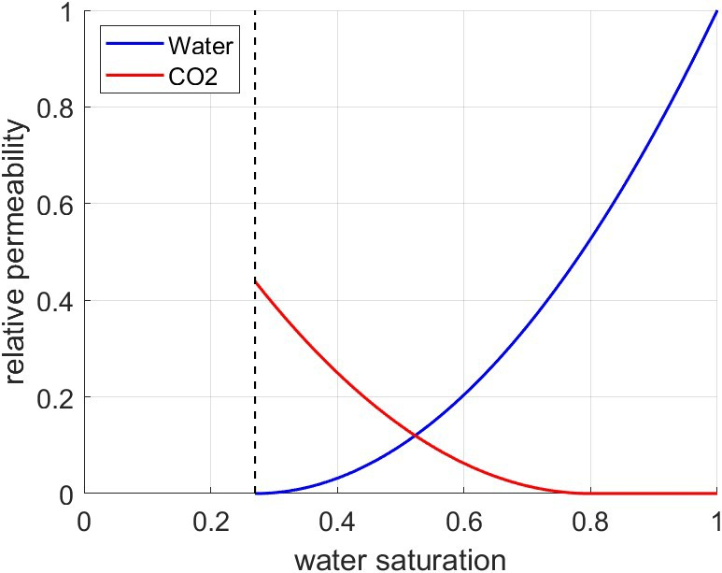

**Figure 4:** Relative permeability curves for the CO2-water system. The residual saturations are 0.27 and

0.2 for water and CO2, respectively.

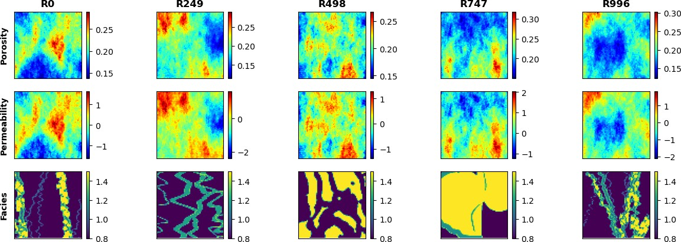

**Figure 5:** Spatial distribution of porosity (top), permeability (middle), and facies (bottom) for 5 random realizations.

permeability (*k*) distributions with a wide range of values, as shown in Figure 5. Facies distributions are

obtained from a library of deepwater fluvial training images [73, 74]. These encompass a wide range of

possible geologic scenarios including marked point (lobe, ellipse, and bar), FluvSim (channel, channel-levee,

and channel-levee-splay), surface based (compensational cycles of lobes), and bank retreat (channel complex).

To generate consistent porosity and permeability distributions with the facies-based geologic scenarios, we

condition the original porosity and permeability distributions to the facies distributions. The resulting fluvial

distributions are shown in Figure 6.

The conditional fluvial porosity and permeability distributions are used as input models for the numerical

simulation of geologic CO2 storage using MRST [75] to calculate the response models for training our proposed model. Specifically, the MRST-co2lab module is used as an

automatic-differentiation framework for the compositional simulation of the two-phase CO2-water problem.

The reservoir is initialized as a fully water saturated zone (i.e., aquifer) with an initial pressure of 4,000 psi.

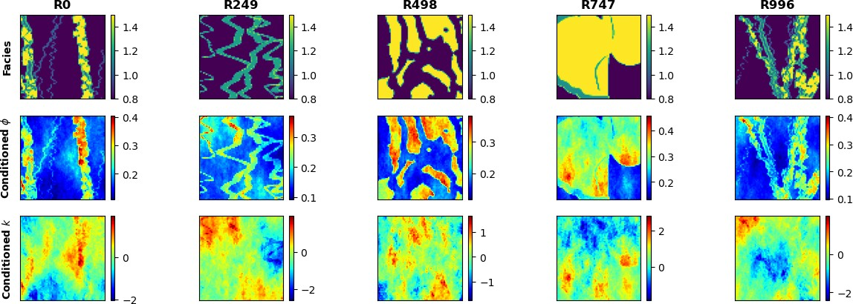

**Figure 6:** Spatial distribution conditioned to facies (top) for porosity (middle) and permeability (bottom) for 5 random realizations.

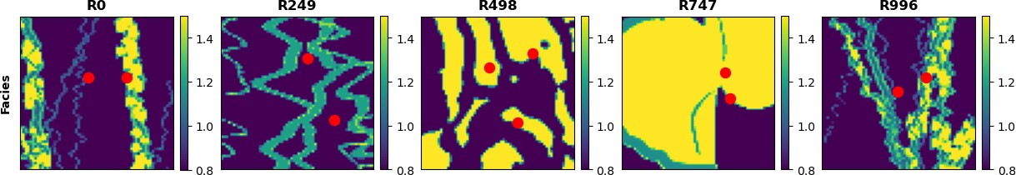

**Figure 7:** CO2 injection well(s) location (red) overlaid over facies distributions for 5 random realizations.

The reservoir has constant isothermal conditions and constant pressure boundary conditions to represents a

arge-scale geologic CO2 storage project with negligible dip, such as found in the Illinois Basin and parts of

the North Sea and Gulf of Mexico.

The model has dimensions of 1km-1km-100m in the x-, y-, and z-directions, respectively. We use 64

uniform grid cells in the x- and y-directions. The grid design is sufficiently refined to resolve the pressure

and saturation plumes in highly heterogeneous reservoirs while remaining computationally tractable for the

purpose of training deep learning models. A random number of injection wells, *w ∈* [1*,* 3], are placed randomly

along the reservoir for each of the 1,000 realizations, no closer than 250m from the boundaries, as shown in

Figure 7. The injection well(s) are randomly placed and not conditioned to zones of preferential porosity,

permeability, nor facies. Each injection well has a constant radius of 0.1m and a single and continuous

perforation that injects pure supercritical CO2 at a constant rate such that the total injection rate of the *w*

well(s) is 0.5 megatons per year.

The numerical simulation is run for 5 years, monitored monthly, for a total of 60 timesteps. At each

grid cell and for each time step, we resolve the implicit pressure, explicit saturation (IMPES) formulation of

196 Eq. (1) to obtain the corresponding dynamic pressure and saturation distributions over time (videos) from

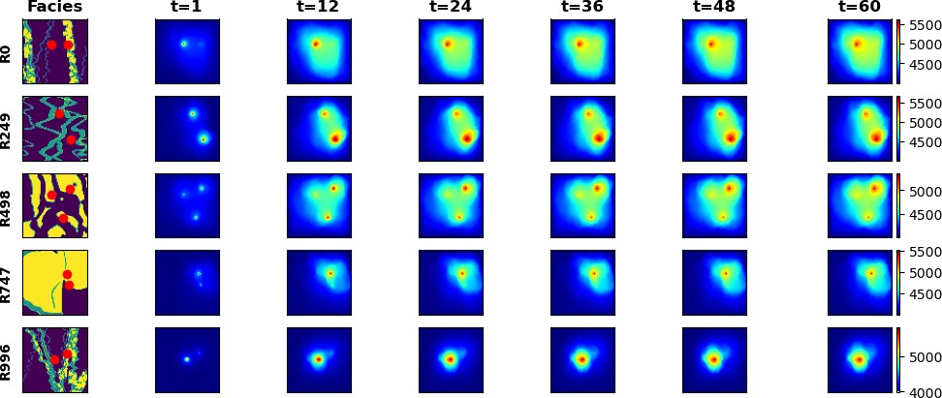

**Figure 8:** Pressure response distributions over time for 5 random realizations obtained from HFS (in psia).

the static geologic realizations of porosity and permeability conditioned to the fluvial facies (images) with

random well(s) configuration. The pressure and saturation responses corresponding to

geologic model realizations are shown in Figures 8 and 9, respectively.

# 2.3 Proxy Model Architecture

Our proposed Stochastic pix2vid image-to-video data-driven method, is a mapping operator from the

static realizations of geologic distributions of porosity, permeability and facies as well as the injector well(s)

distribution, to the dynamic responses of pressure and saturation distributions over time. A single model is

trained to predict both pressure and saturation distributions over time as a multi-channel output from the

multi-channel input features, porosity and permeability.

Let *m* represent a geologic model realization of porosity, permeability, facies, and injector well(s) distri-

butions, such that *m* = *{ϕ, k, facies, w}*. The dynamic responses of pressure and saturation over time are

given by *d* = *f* (*m*), such that *d* = *{P* (*t*)*, S*(*t*)*}* and *f* is the physics-based numerical reservoir simulation.

Our aim is to replace *f* with a more efficient data-driven proxy by training the Stochastic pix2vid model.

For this purpose, we exploit the latent structures in space and time of the static inputs and dynamic outputs

through a spatiotemporal encoder-decoder architecture.

The encoder portion of the network is comprised of sequential convolutional layers to compress the

spatial features of the subsurface realizations into a latent parameterization *zm*, given by *zm* = *Enc*(*m*). In their

compressed representation, these features represent the salient characteristics of the geologic distributions.

The decoder portion of the network is designed as a series of recursive residual convolutional-recurrent layers,

such that the latent space *zm* is recursively decoded into the dynamic distributions of pressure and saturation

over time. The previous timestep latent representations, *zt* , are used in the subsequent timestep to refine

*d*

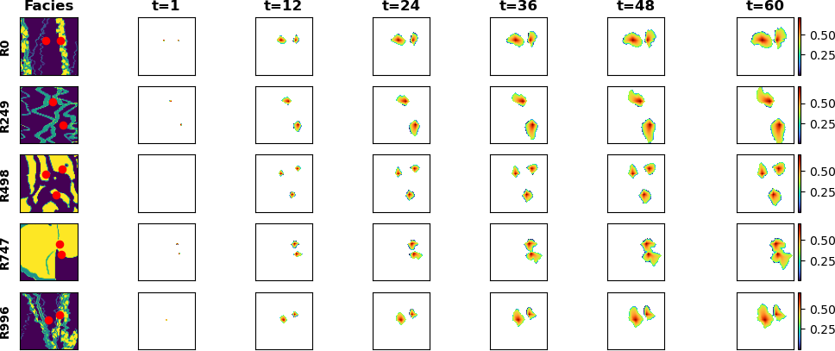

**Figure 9:** Saturation response distributions over time for 5 random realizations obtained from HFS.

the outputs and reduce systematic error propagation in time. Thus, the full architecture is represented as

*d*ˆ= *Dect*([*Enc*(*m*); *zt* ]) (6)

*d*

The encoder, *Enc,* compresses the geologic realizations, *m*, into a latent representation *zm* through the

use of depthwise separable convolutions [76]. This type of convolution learns the parameters for each channel

n the image separately, avoiding mixing of variables or loss of resolution, as shown in Figure 10. This is

especially important when dealing with discrete, non-smooth porosity and permeability spatial distributions due to dicrete facies and binary well(s) location distributions. Each separable convolution layer is

regularized with an *l*1-norm weight of 1 *×* 10*−*6 to control the null space in latent feature space. Moreover,

we use a Squeeze-and-Excite layer to improve channel interdependence, and to avoid mixing and loss of

esolution [77]. Each Squeeze-and-Excite layer will provide the optimal network weights for each channel

independent of the other channels by passing the feature maps through a global pooling layer (squeeze) and a

dense layer with nonlinear activation (excite), to add content aware mechanism for re-weighting each channel

daptively, as shown in Figure 11. Furthermore, by applying instance normalization, as opposed to the more

common batch normalization, we achieve channel-independent normalization of the convolved features [78].

instance normalization is a special case of group normalization, where the numbers of channels per group is

exactly 1, such that each channels gets its own normalization scheme, as shown in Figure 12. Parametric

rectified linear units (PReLU) is used as the activation function, where at each minibatch iteration, the

network learns the optimal leaky slope for activation in each layer, as shown in Figure 13. Finally, pooling

and spatial dropout are applied, as the resulting feature map is reduced to half the input dimension. Through

236 3 convolutional encoding layers with filter size 3 *×* 3, we obtain the latent parameterizations *z*1 , *z*2 , and *z*3 .

237

Table 1 summarizes the architecture and dimensions of each layer.

*m m m*

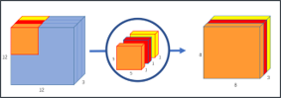

**Figure 10:** Schematic for a separable convolutional layer. Each channel is convolved with its own set of convolutional filters to obtain the best representation, as opposed to traditional convolutions where the same filter is applied to all channels in the data.

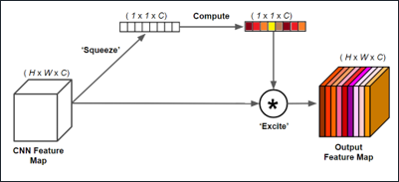

**Figure 11:** Schematic for a squeeze-and-excite layer. The ”squeeze” layer takes the global average of the data for each channel, and the ”excite” layer is a fully-connected layer with nonlinear activation to estimate the optimal weights for each channel in the data. The result is a weighted representation of the data based on their intrinsic global characteristics.

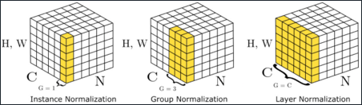

**Figure 12:** Schematic for instance normalization (left) compared to group normalization (center) and batch normalization (right). In an instance normalization layer, each channel will be normalized by themselves rather than normalizing the entire batch or a subset of channels (groups).

The decoder portion of the Stochastic pix2vid model extracts the spatiotemporal relationships from the

latent representations of *m* to reconstruct the dynamic pressure and saturation distributions over time, *d*.

To accurately reconstruct the spatiotemporal structure from the static latent space, *zm*, we employ a series

of convolutional-recurrent layers, namely a convolutional long-short term memory layer (ConvLSTM). The

general form of a 2D ConvLSTM layer is shown in Figure 14. Through 3 convolutional-recurrent layers, we

obtain the dynamic prediction of *d* as follows:

Step 1: **Spatiotemporal decoding of** *z*3 : The first ConvLSTM layer takes the smallest latent represen-

tation, *z*3 , and reconstructs the first decoded timestep *z*3.

*m d*

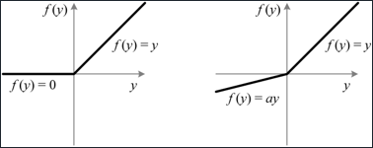

**Figure 13:** Schematic for the Parametric Rectified Linear Unit (PReLU) activation function (right) com- pared to the traditional ReLU activation function (left). The slope of the negative portion of the data, *α*, is learned for each batch.

**Table 1:** Encoder network architecture

|  |  |  |
| --- | --- | --- |
| **Layer Number Architecture** | **Shape in**  (h,w,c) | **Shape out**  (h,w,c) |
| SeparableConv2D | 64 *×* 64 *×* 4 (*m*) |  |
| Squeeze-and-Excite |  |  |
| 1 Instance Norm |  |  |
| PReLU + Pooling  Spatial Dropout |  | 32 *×* 32 *×* 64 (*z*1 )  *m* |
| SeparableConv2D | 32 *×* 32 *×* 64 |  |
| Squeeze-and-Excite |  |  |
| 2 Instance Norm |  |  |
| PReLU + Pooling  Spatial Dropout |  | 16 *×* 16 *×* 128 (*z*2 )  *m* |
| SeparableConv2D | 16 *×* 16 *×* 128 |  |
| Squeeze-and-Excite |  |  |
| 3 Instance Norm |  |  |
| PReLU + Pooling  Spatial Dropout |  | 8 *×* 8 *×* 256 (*z*3 )  *m* |

|  |  |  |
| --- | --- | --- |
| 246 | Step 2: | **Residual concatenation of** *z*2 : The first decoded timestep, *z*3, is concatenated with the inter-  *m d* |
| 247 |  | mediate static encoding *z*2 to retain multi-scale features and improve prediction performance and  *m* |
| 248 |  | resolution. |
| 249 | Step 3: | **Intermediate spatiotemporal decoding**: The second ConvLSTM layer takes the residual con- |
| 250 |  | catenation of the intermediate latent representations, [*z*2 *, z*3], to predict the next spatiotemporal  *m d* |
| 251 |  | representation *z*2.  *d* |
| 252 | Step 4: | **Residual concatenation of** *z*1 : The intermediate decoded timestep, *z*2, is concatenated with the  *m d* |
| 253 |  | largest static encoding *z*1 .  *m* |
| 254 | Step 5: | **Final spatiotemporal decoding**: The third ConvLSTM layer takes the residual concatenation of |
| 255 |  | the larger latent representations, [*z*1 *, z*2], to predict the full-scale dynamic output, *d*.  *m d* |

256 To enhance the performance of the spatiotemporal decoding, each ConvLSTM layer is followed by a batch

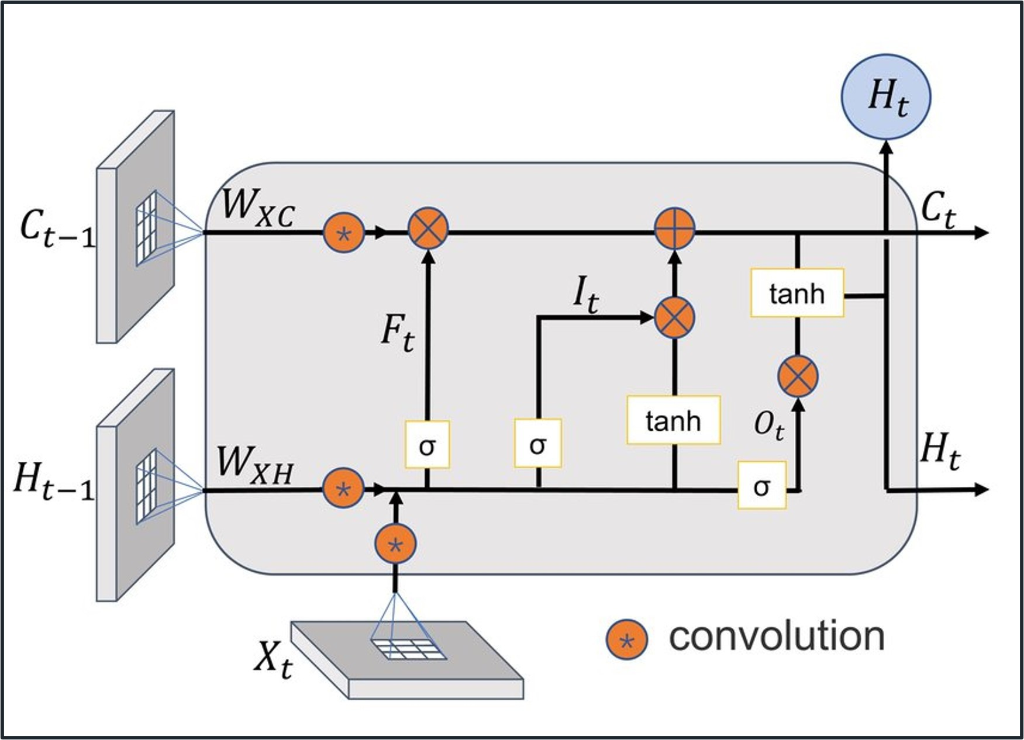

**Figure 14:** Schematic of a convolutional-LSTM (ConvLSTM) layer. The layer applies convolutional opera- tions to the input data using a set of learnable filters to capture the spatial patterns. The recurrent part is a long short-term memory layer with memory and forget gates to capture the temporal patterns. LSTM units are applied to each spatial location separately allowing to capture both spatial and temporal dependencies in the data.

normalization, activation, and a transpose convolutional layer, the latter for downscaling the latent features

to twice their dimension. Spatial dropout is applied, and the concatenated features are once more convolved

and activated to obtain the layer prediction. Table 2 shows the architecture of the decoder network.

This process yields the first video frame prediction, *d*1, from the latent representation of the geologic

realizations *zm*. Each subsequent video frame prediction is obtained by another set of residual concatenation

of the previous timestep dynamic decoded representation. The static latent representation *zm* is concatenated

at each timestep with the previous dynamic decoded representation for each layer such that we have [*zm, zi* ],

where *i* is the decoding layer number and *t* is the timestep. By recursively implementing spatiotemporal

decoding to the latent representation *zm*, we obtain the prediction of the dynamic response *dt* at times for

each timestep *t* = 1*, . . . , n*.

The complete Stochastic pix2vid architecture is shown in Figure 15. Here we observe the spatial com-

pression of the geologic models, *m*, through the encoding portion of the network, and the spatiotemporal

decoding and residual multi-scale concatenations through the decoder portion of the network. The result-

ing architecture provides proxy model from a subsurface static uncertainty model (images) to subsurface dynamic response

(videos).

# 2.4 Training Strategy

The inputs to the Stochastic pix2vid are the geologic realizations, comprised of the distributions of

porosity, permeability, facies, and injection well(s) location, represented as a matrix *m* of dimensions 64 *×*

64 *×* 4. The outputs are the results from the numerical reservoir simulation, namely pressure and saturation

276 distributions over time, represented as a matrix *d* of dimensions 64 *×* 64 *×* 60 *×* 2. This yields an ill-posed

**Table 2:** Decoder network architecture

# Layer Number Architecture Shape in Shape out

(t,h,w,c) (t,h,w,c)

ConvLSTM2D 1 *×* 8 *×* 8 *×* 256

BatchNorm + LeakyReLU

Conv2DTranspose

1. Spatial Dropout

Concatenate (*z*3 )

*m*

Conv2D + Sigmoid *t ×* 16 *×* 16 *×* 128 (*z*3 )

*d*

*t*

ConvLSTM2D *t ×* 16 *×* 16 *×* 128

BatchNorm + LeakyReLU

Conv2DTranspose

1. Spatial Dropout

Concatenate (*z*2 )

*m*

Conv2D + Sigmoid *t ×* 32 *×* 32 *×* 64 (*z*2 )

*d*

*t*

ConvLSTM2D *t ×* 32 *×* 32 *×* 64

BatchNorm + LeakyReLU

1. Conv2DTranspose Spatial Dropout

Concatenate (*z*1 )

*m*

Conv2D + Sigmoid *t ×* 64 *×* 64 *×* 2 (*z*1 )

*d*

*t*

and under-determined estimation problem, which are difficult to resolve [79, 80]. To improve

the training efficiency and performance, we subsample in time from 60 timesteps to 11. In other words,

instead of monthly monitoring, we predict the dynamic outputs at the initial step and every 6 months

afterward; therefore the output matrix *d* a final dimension of 64 *×* 64 *×* 11 *×* 2. We also perform min-max

normalization so that the input and output features are in the range of [0*,* 1], which greatly improves the

performance of the nonlinear activation functions. Furthermore, we perform data augmentation by 90*◦*

image rotation, making the network agnostic to orientation to encourage effectively learning the flow physics in the system

rather than memorizing spatial distribution patterns. The total amount of training data is therefore 2,000

realizations (after augmentation), which is split into 1,500 realizations for training and 500 realizations for

testing. To improve model generalizability, at each epoch, each minibatch is split into 80/20 for training and

validation sets, respectively.

A custom three-part loss function is used to accurately predict pixel-wise and perceptual information in

the predictions. The mean squared error (MSE) is used to reconstruct the pixel-wise intensity values, while

the mean absolute error (MAE) is used to optimize for the pressure and saturation plume edges. The third

part is the structural similarity index metric (SSIM), which provides a perceptual image-to-image comparison

of luminance, contrast, and structure [81]. For optimal training, the aim is to minimize the MSE and MAE

while maximizing the SSIM for the true versus predicted outputs, *d* and *d*ˆ, such that the total loss is given

294 by:

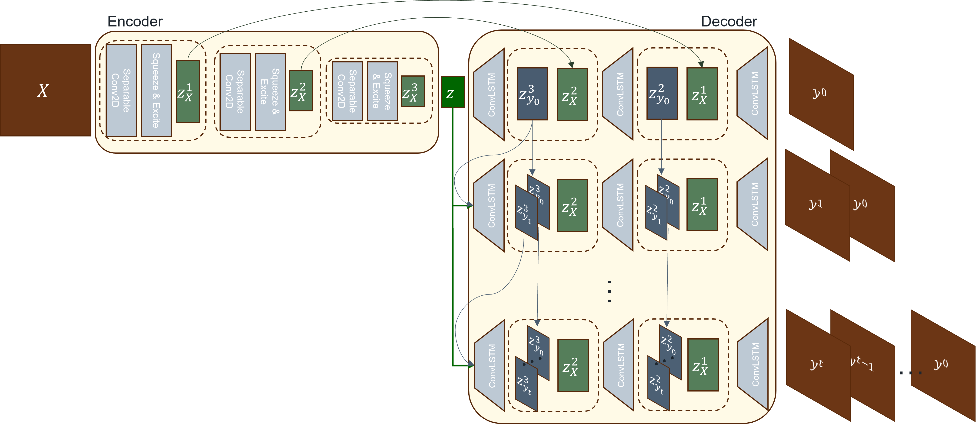

**Figure 15:** Architecture of our proposed Stochastic pix2vid method. The input data, *X ≡ m*, is encoded through a series of convolutional layers to capture the spatial dependencies in the geologic models. The latent representation, *zm*, is recursively passed through a spatiotemporal decoder with convolutional-recurrent layers, and concatenated with the residuals of the encoder to reconstruct iteratively the frames of the output (video) data, *y ≡ d*.

*L* = *α*(1 *− SSIM* ) + (1 *− α*)[*βMSE* + (1 *− β*)*MAE*] (7)

where *α* and *β* are weighting coefficients obtained empirically as 0.33 and 0.66, respectively.

The model is trained using the AdamW optimizer [82]. This variant of the well-known adaptive mo-

mentum (Adam) optimizer [83] includes an added method to decay weights for the adaptive estimation of

first-order and second-order moments. We implement a learning rate of 1 *×* 10*−*3 with a weight decay term

of 1 *×* 10*−*5.

**3 Results**

This section describes the Stochastic pix2vid model training performance and discusses the application of

the proxy to rapidly forecast CO2 plume migration for a large-scale GCS operation.

# 3.1 Training Performance

Using an NVIDIA Quadro M6000 GPU, we train for 100 epochs with a batch size of 50. The model has

a total of 97,523,370 parameters, and the training time required is approximately 88 minutes for all 1,500

raining realizations. The training and validation performance per epoch is shown in Figure 16. We observe

minimal overfit in the validation set, corresponding to good model generalizability and prediction accuracy

within the training data. Using physics-based numerical simulation, each realization requires approximately

30 seconds to obtain the dynamic pressure and saturation predictions from the static geologic models. Our

Stochastic pix2vid model obtains the same results in approximately 4.59 milliseconds, corresponding to a

6,500× speedup. The average MSE for the ensemble is 9*.*21 *×* 10*−*4 and 9*.*70 *×* 10*−*4 for training and testing,

respectively. Similarly, the average SSIM for the ensemble is 98*.*97% and 97*.*91% for training and testing,

respectively.

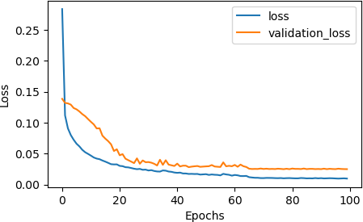

**Figure 16:** The total training and validation losses, *L*, as a function of epoch number.

# 3.2 Prediction Results

After training the Stochastic pix2vid model with 1,500 realizations of static geologic models, *m* =

*{ϕ, k, facies, w}*, to predict the dynamic reservoir response, *d* = *{P* (*t*)*, S*(*t*)*}*, we can compare the per-

formance of the predictions for the training and unseen testing data.

Figures 17 and 18 show the predicted dynamic pressure and saturation distributions, respectively, along

with the absolute difference to HFS for 3 training realizations. We observe reasonable agreement between

the true and predicted CO2 pressure and saturation plumes over time, pixel-wise with an average MSE of 3*.*25 *×* 10*−*4

and perceptually with SSIM of 98*.*59% for pressure predictions and MSE of 1*.*50 *×* 10*−*4 and SSIM of 97*.*31% for saturation

predictions.

Similarly, Figures 19 and 20 show the pressure and saturation distributions predictions along with the

absolute difference to HFS for 3 testing realizations. We observe a similar performance, with an average MSE

of 3*.*71 *×* 10*−*4 and SSIM of 97*.*55% for pressure predictions and MSE of 1*.*61 *×* 10*−*3 and SSIM of 96*.*19% for

saturation predictions. This indicates that the Stochastic pix2vid model is generalizating ability

and achieves on par performance with HFS at a fraction of the computational cost.

It is interesting to note that the Stochastic pix2vid model is trained on a triple-loss function with MSE,

MAE and SSIM. For both training and testing cases, we see that the average MSE for pressure is higher

than that of saturation, while the opposite is true for the average SSIM. This can be attributed to the fact

that there are more pixel-wise variations in pressure predictions, thus the loss focuses on matching those

332 individual pixel-wise values. On the other hand, for saturation predictions, the contrast, luminance, and

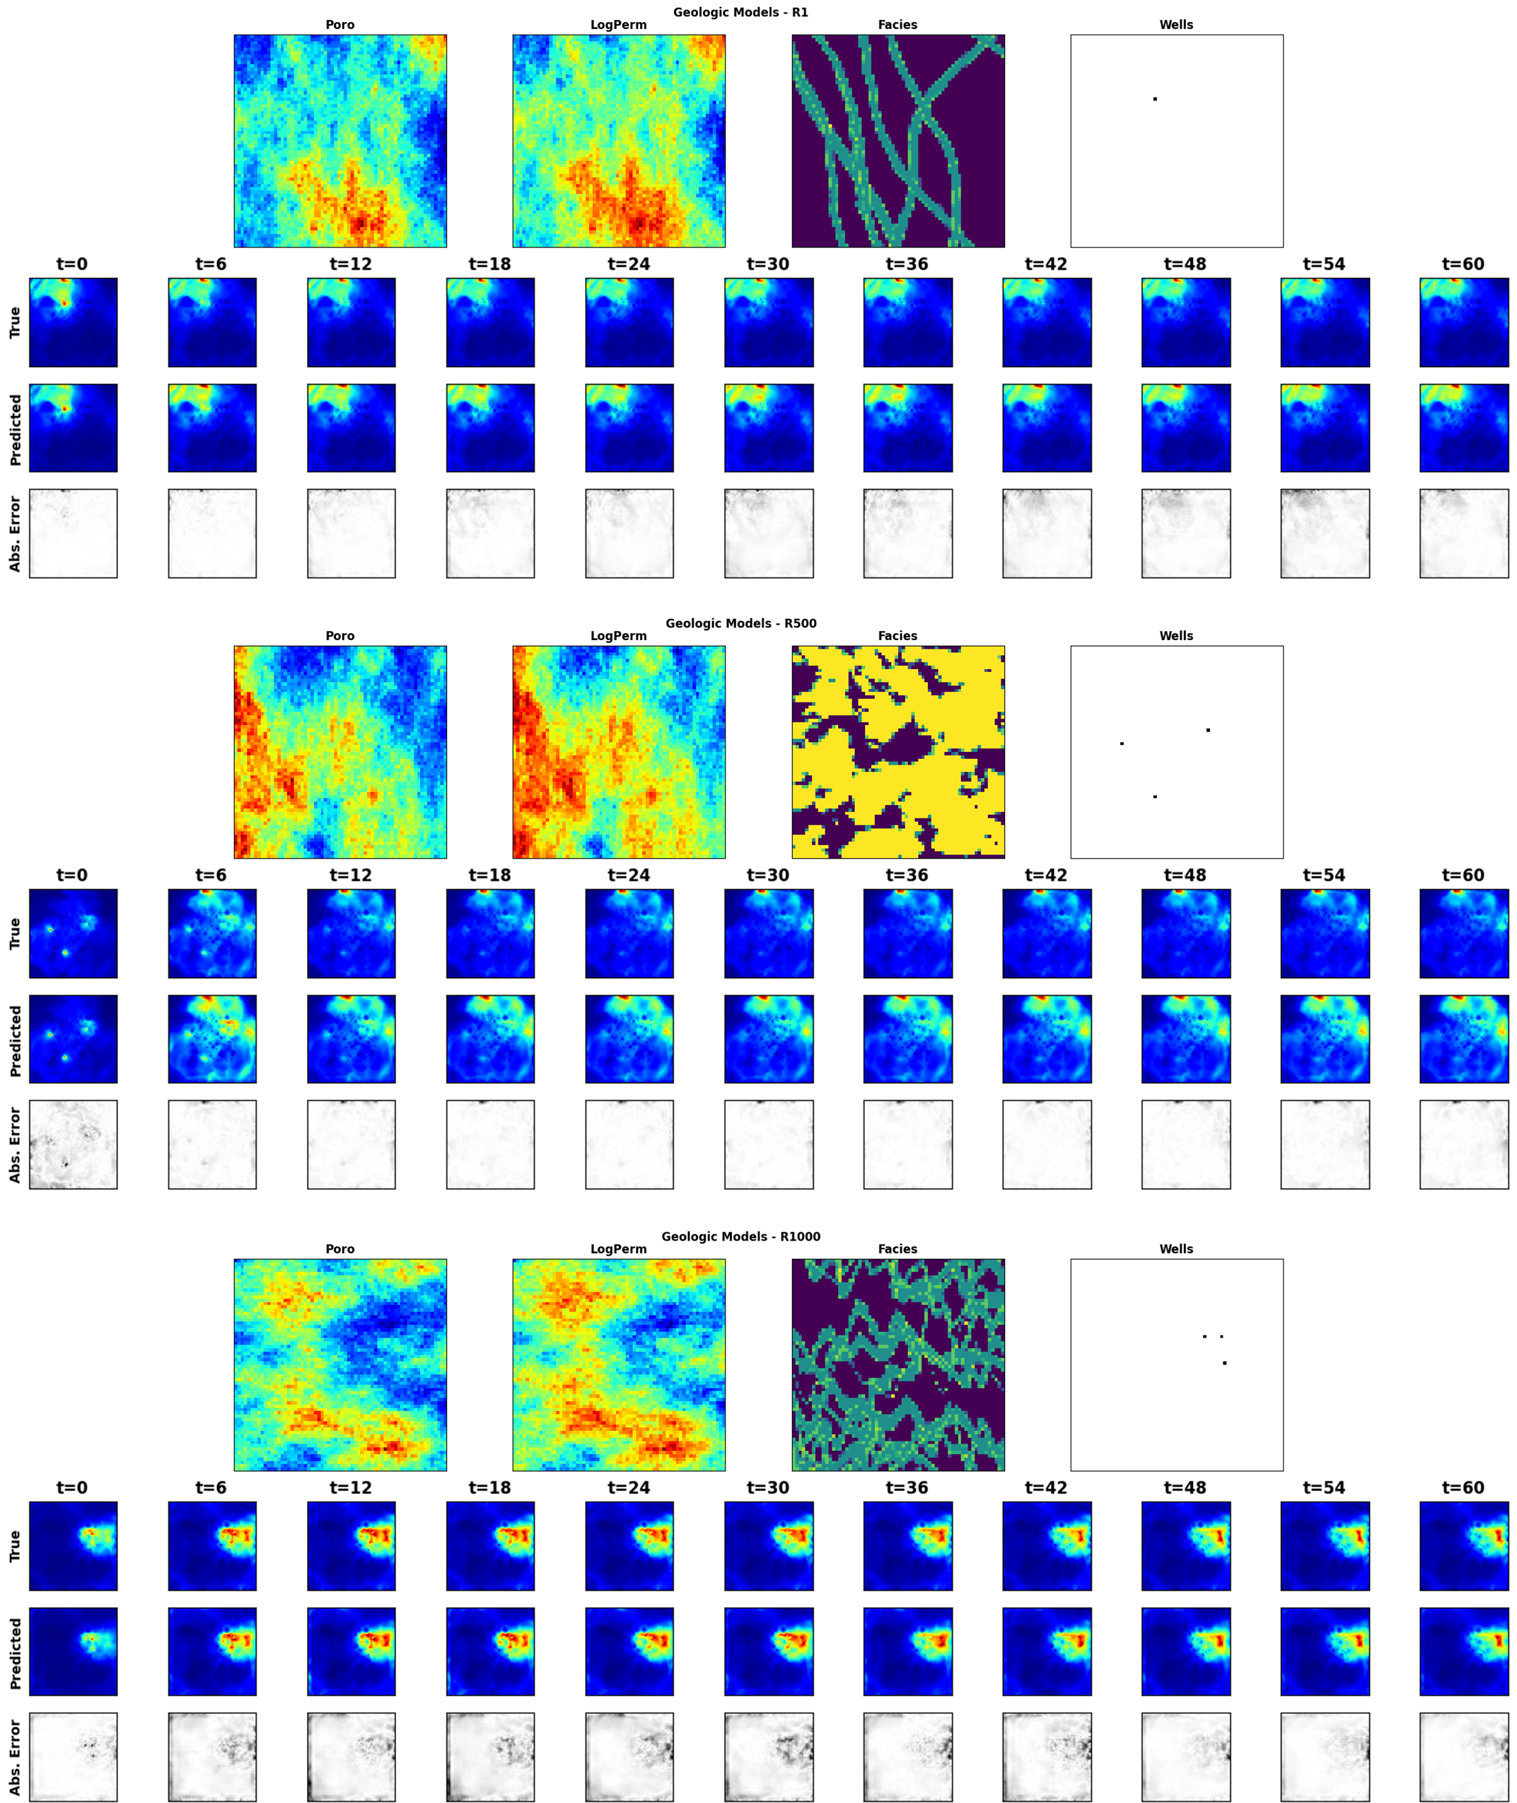

**Figure 17:** Normalized pressure distribution over time for 3 random training realization. For each panel, the top row is the ground truth from the HFS, the middle row is the Stochastic pix2vid prediction, and the bottom row is the absolute difference to HFS.

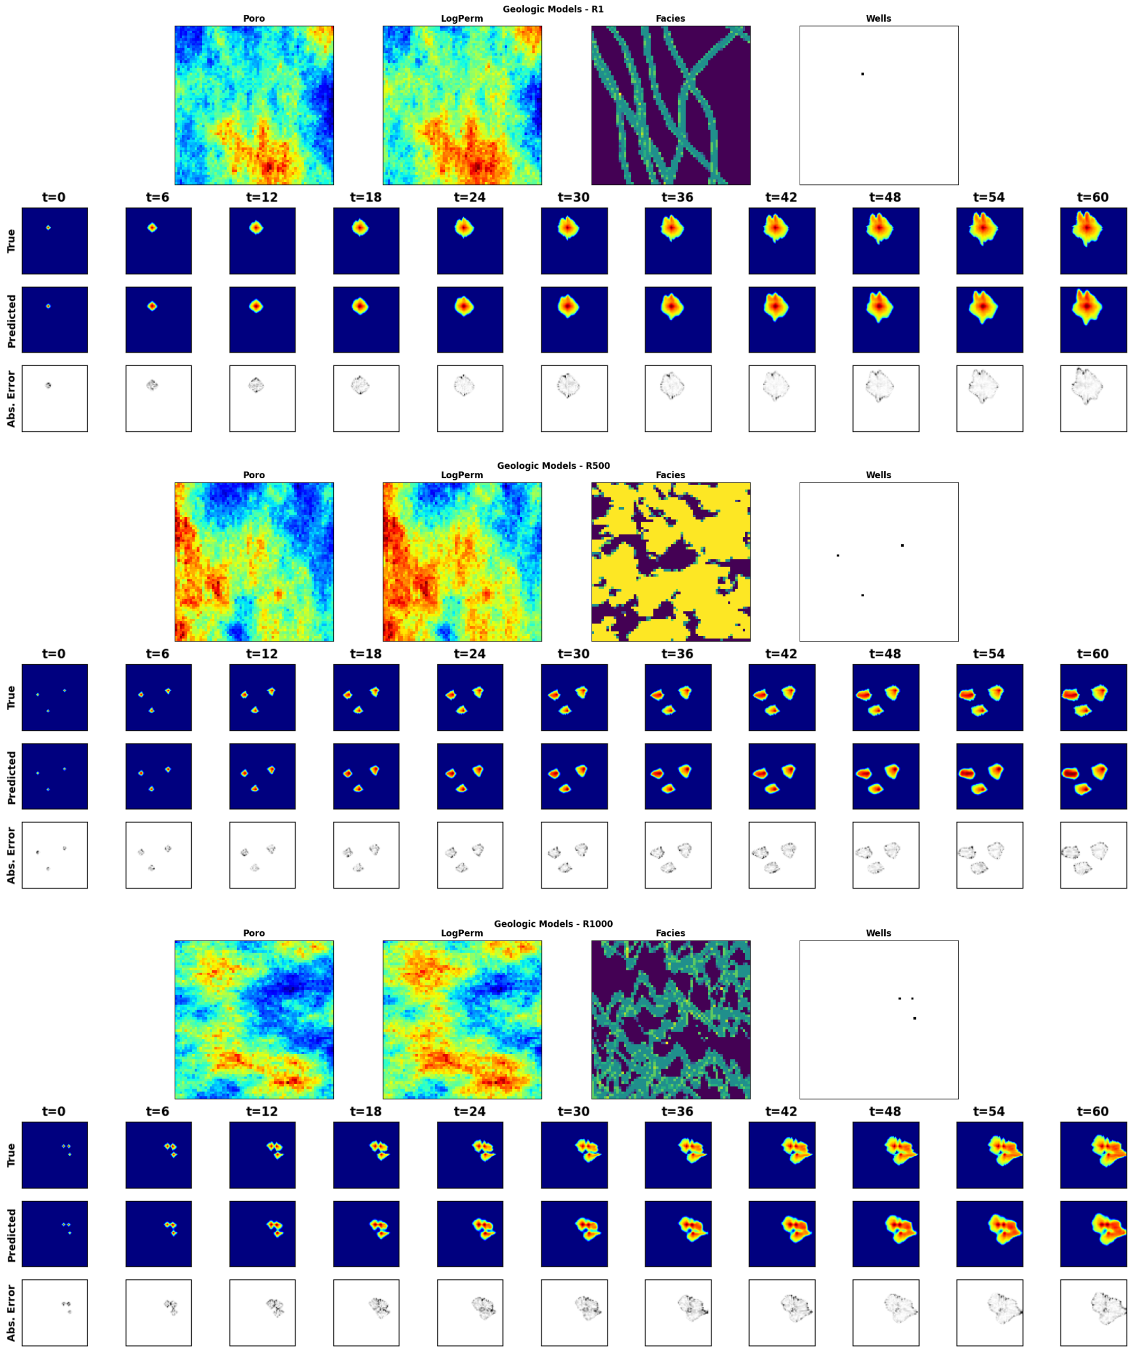

**Figure 18:** Saturation distribution over time for 3 random training realization. For each panel, the top row is the ground truth from the HFS, the middle row is the Stochastic pix2vid prediction, and the bottom row is the absolute difference to HFS.

structure play a bigger role in the prediction that the pixel-wise intensity values. Therefore, it is important

to take into account both metrics for training and validating spatiotemporal subsurface prediction models.

From Section 2.3, the first step of the Stochastic pix2vid model is to take the static geologic realizations,

*m*, and compresses them into a latent space representation, *zm*, using the spatial encoder structure. Figure

21 show a random selection of latent feature maps, along with their superposition on the porosity and facies

distribution. This can be interpreted as an analog to the attention head mechanisms recently developed

in transformer-based architectures [84]. We observe that the latent feature maps are essentially learning

the injection location(s) and direction of flow based on the geologic distributions. Thus, proving that the

Stochastic pix2vid model is learning multiphase flow physics and dynamic reservoir behavior appropriately.

These results imply that our Stochastic pix2vid is capable of learning the spatiotemporal relationship be-

tween the static geologic models and the dynamic reservoir response. Thus, our image-to-video architecture

can outperform current image-to-image and encoder-recurrent-decoder architectures to provide improved

reservoir behavior prediction closer to that of traditional numerical simulation. To quantify the uncer-

tainty in predictions, a comparison of true (*d*) versus predicted (*d*ˆ) response for pressure and saturation

distributions for the testing data is shown in Figure 22. The average *R*2 over time is approximately 99%

with narrow 95% prediction bands that recursively narrow over time. From Figure 22 we observe the advan-

tage in implementing recursive refining of predictions over time with recurrent residual connections in the

spatiotemporal decoder network, thus reducing the spatiotemporal uncertainty in the predictions.

CO2 saturation and pressure buildup fronts are important quantities for geologic CO2 storage projects

and are often used for regulatory oversight [85, 86], monitoring metrics or history matching purposes [87, 88].

The distance between the injection well(s) and the saturation fronts represents the maximum extent of the

CO2 plume; however, these are often very difficult to capture accurately with data-driven proxy models.

Our Stochastic pix2vid method shows greater absolute error on and around the plume fronts compared to

within the plumes. However, the overall shape and intensity of the pressure and saturation distributions over

time is very well captured for all realizations despite being highly heterogeneous. Therefore, the Stochastic

pix2vid model can be used as a reliable replacement for expensive numerical reservoir simulations, especially

in cases where large number of runs are required to obtain dynamic estimates (e.g., well placement and

control optimization, history matching, uncertainty quantification).

**3.3 Discussion**

In our Stochastic pix2vid model, the encoder block is composed of separable convolutions, squeeze and

excite layers, and instance normalization. These three particular implementations allow for precise param-

eterization of the geologic realization into a latent representation, without mixing the effects of Gaussian-

distributed properties against binary of binomial-distributed properties. Using recursive residual ConvLSTM

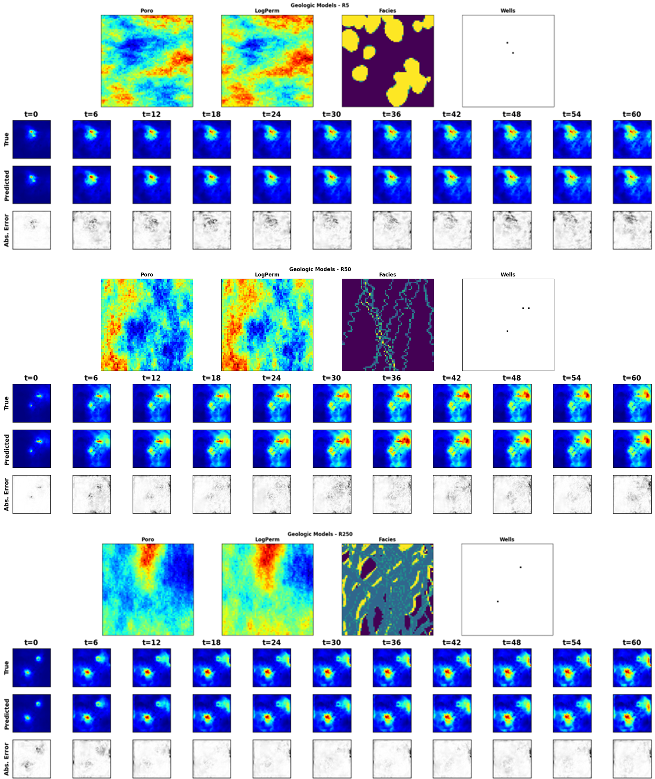

**Figure 19:** Normalized pressure distribution over time for 3 random testing realization. For each panel, the top row is the ground truth from the HFS, the middle row is the Stochastic pix2vid prediction, and the bottom row is the absolute difference to HFS.

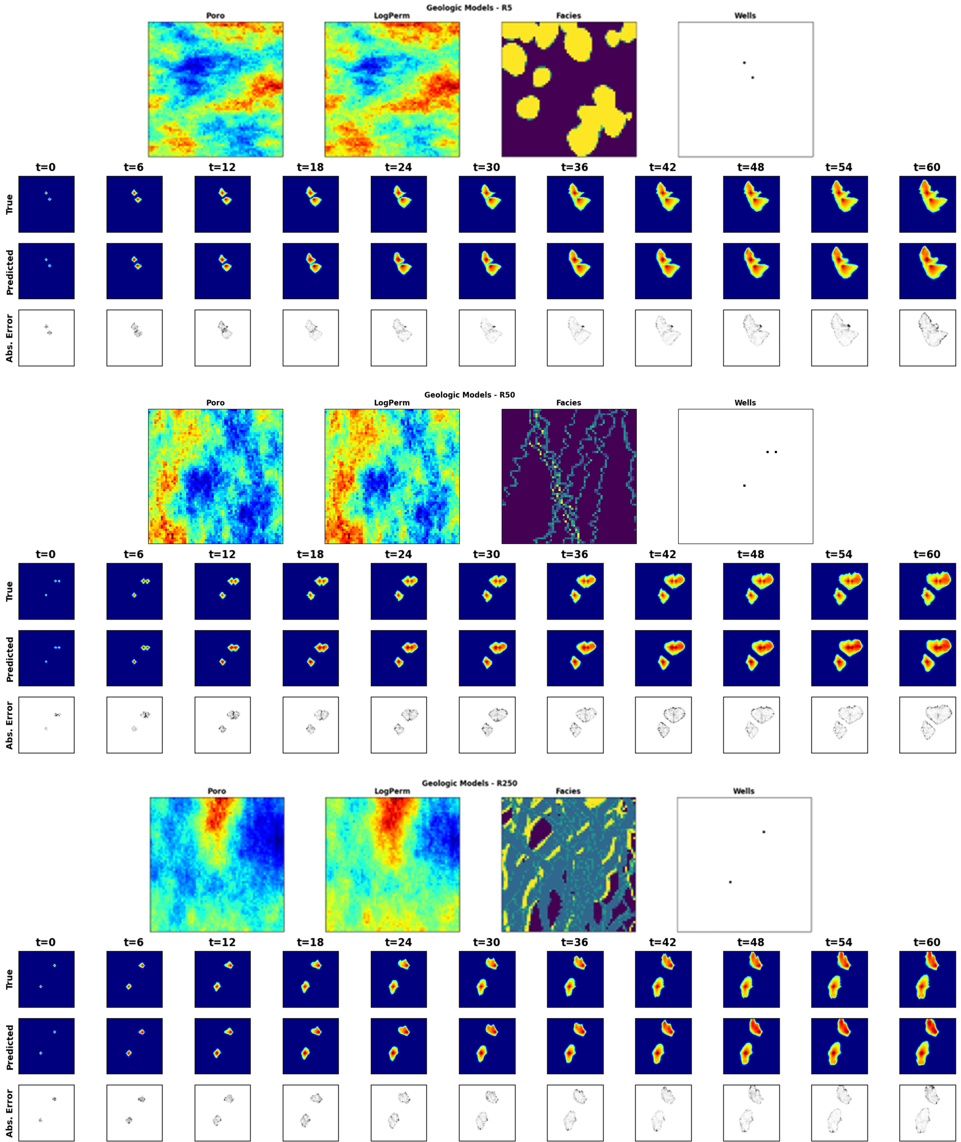

**Figure 20:** Saturation distribution over time for 3 random testing realization. For each panel, the top row is the ground truth from the HFS, the middle row is the Stochastic pix2vid prediction, and the bottom row is the absolute difference to HFS.

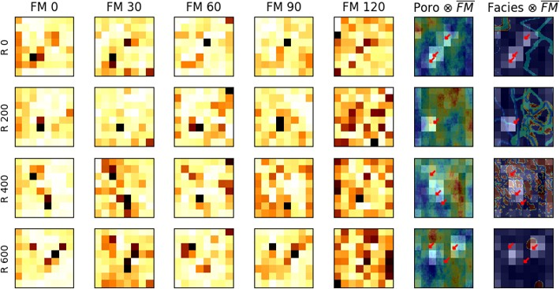

**Figure 21:** Five random feature maps (FM) of *z*3

*m*

for 4 random realizations. Their average is superimposed on

top of the porosity and facies distributions to show the attention mechanism of the encoder. Bright colors

represent higher attention and dark colors represent lower attention.

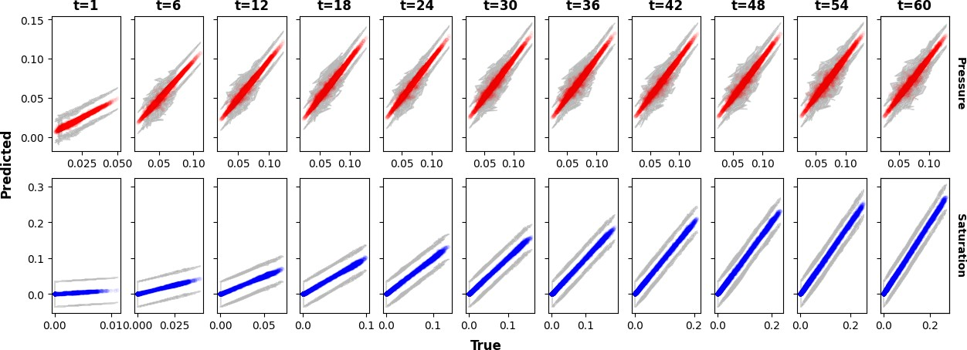

**Figure 22:** True versus predicted average normalized pressure (top) and saturation (bottom) over time for the testing data. The gray portion represents the 95% confidence bands, which narrow over time.

layers, the decoder block iteratively predicts each dynamic state, or video frame, from the concatenation

of the previous dynamic latent representation and the intermediate encoding parameterizations. Thus, our

architecture makes the proxy model an image-to-video prediction formulation for dynamic reservoir states

from a static geologic realization.

By using GPU-enabled computations, we significantly accelerate the training and prediction time of the

Stochastic pix2vid model. Each HFS run was performed on an Intel ®i9-10900KF processor with 10 cores.

The 1,000 realizations are parallelized equally among all cores and the total simulation time accounting for

parallelization for all realizations is about 8.33 hours. Dynamic prediction of the 1,000 realizations using

the Stochastic pix2vid model on an NVIDIA Quadro M6000 GPU require a total of 4.6 seconds, or 0.001275

hours, with an accuracy of 99% and 98% for training and testing, respectively. This provides a sustainable

argument for the usage of our Stochastic pix2vid model as a replacement for HFS when computational time

is a constraint.

To further demonstrate the effectiveness of our Stochastic pix2vid model for geologic CO2 storage op-

erations, we plot the cumulative pixel-wise CO2 saturation as a surrogate for the cumulative CO2 volume

injected. For all training and testing realizations, Figure 23 shows the sum of pixel-wise CO2 saturation and

the probability density function (PDF) of the true versus predicted saturations. We observe an *R*2 of 98%

for training and 96% for testing in the cumulative CO2 saturation of true versus predicted results, and a

conformable PDFs for both training and testing.

**4 Conclusions**

We develop a deep learning-based spatiotemporal proxy model to provide efficient flow predictions for a large-scale

GCS operations to support optimum decision making …. Our proposed method, Stochastic pix2vidThe introduces the use of a spatiotemporal convolutional-recurrent archi-

tecture for dynamic predictions of CO2 pressure and saturation distributions over time from a static geologic

realization representing the subsurface uncertainty model. The framework is developed as an image-to-video

prediction, which is an under-determined estimation problem. Specifically, the implementation expands upon

the architectures of current encoder-recurrent-decoder models and provides a fast and accurate proxy as a

replacement for physics-based numerical reservoir simulation.

The spatiotemporal proxy is applied to a synthetic 2D GCS project with multiple uncertain geologic

scenarios and random number and location of injection well(s). A total of 1,000 geologic models are obtained

from a variety of possible geologic scenarios including fluvial, turbidite, and deepwater lobe systems. The

spatial distribution of porosity, permeability and facies, and the spatial location of the injector well(s) are used

396 as the input data. The proxy model is used to predict the dynamic reservoir response over time, namely the

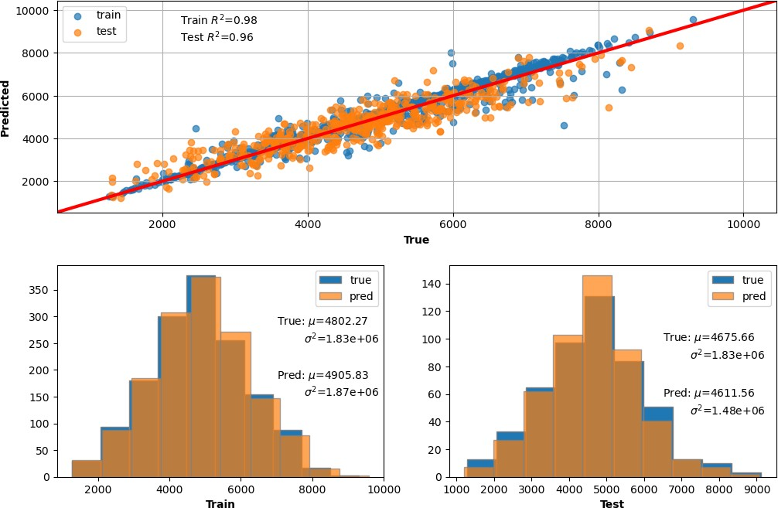

**Figure 23:** (Top) True vs. predicted cumulative CO2 volume injected via pixel-wise saturation. (Bottom) True vs. predicted distributions of cumulative CO2 saturation for training (left) and testing (right).

video frames, corresponding to the dynamic CO2 pressure and saturation distributions, which are obtained

offline for training using HFS. The total training time is 88 minutes on a single NVIDIA Quadro M6000

CPU, and predictions are obtained with 98-99% accuracy within approximately 4.6 milliseconds, compared

to the approximate 30 seconds required for HFS – a 6*,* 500*×* speedup.

LIMITATIONS?

There are several possible opportunities for future work. First, an extension to 3D

geologic models and their corresponding dynamic predictions is key to scaling up this method for real-world

applications. Similarly, although the Stochastic pix2vid proxy model is only trained for GCS prediction, it

is applicable for a range of processes such as ground-water, compositional, geothermal, or conventional oil and gas systems.

Moreover, it is possible to extend the Stochastic pix2vid model from a data-driven mapping operator to

PINN by including the discretized form of the governing PDE in the loss function and minimizing the

residuals. Another future opportunity is to test the performance of the Stochastic pix2vid model on

unseen timesteps, either interpolating the training timesteps or extrapolating beyond the training timesteps.

furthermore, the Stochastic pix2vid model can be used as a proxy in workflows for history matching and

closed-loop reservoir management.

**Reproducibility**

The code will be made publicly available on the author’s repository (github.com/misaelmmorales and

github.com/GeostatsGuy).

**Funding**

This research did not receive any specific grant from funding agencies in the public, or not-for-profit sectors.

**Declarations**

The authors declare no conflict of interests.

**Acknowledgements**

The authors thank the Digital Reservoir Characterization Technology (DIRECT) and Formation Evaluation

(FE) Industry Affiliate Program at the University of Texas at Austin for supporting this work.

421 **References**

422 [1] K. Michael, A. Golab, V. Shulakova, J. Ennis-King, G. Allinson, S. Sharma, and T. Aiken. Ge-

423 ological storage of co2 in saline aquifers—a review of the experience from existing storage opera-

424 tions. *International Journal of Greenhouse Gas Control*, 4(4):659–667, 2010. ISSN 1750-5836. doi:

425 https://doi.org/10.1016/j.ijggc.2009.12.011.

426 [2] A. Goodman, G. Bromhal, B. Strazisar, T. Rodosta, W.F. Guthrie, D. Allen, and G. Guthrie. Com-

427 parison of methods for geologic storage of carbon dioxide in saline formations. *International Journal of*

428 *Greenhouse Gas Control*, 18:329–342, 2013. doi: 10.1016/j.ijggc.2013.07.016. cited By 48.

429 [3] J.S. Levine, I. Fukai, D.J. Soeder, G. Bromhal, R.M. Dilmore, G.D. Guthrie, T. Rodosta, S. Sanguinito,

430 S. Frailey, C. Gorecki, W. Peck, and A.L. Goodman. U.s. doe netl methodology for estimating the

431 prospective co2 storage resource of shales at the national and regional scale. *International Journal of*

432 *Greenhouse Gas Control*, 51:81–94, 2016. doi: 10.1016/j.ijggc.2016.04.028. cited By 81.

433 [4] Bert Metz, Ogunlade Davidson, HC De Coninck, Manuela Loos, and Leo Meyer. *IPCC special report*

434 *on carbon dioxide capture and storage*. Cambridge: Cambridge University Press, 2005.

435 [5] Energy 2020. European commission. In *A strategy for competitive, sustainable and secure energy*, 2010.

436 [6] United nations. Agreement, p. *United Nations Treaty Collect*, pages 1–27, 2015.

437 [7] S. Bachu. Review of co2 storage efficiency in deep saline aquifers. *International Journal of Greenhouse*

438 *Gas Control*, 40:188–202, 2015. doi: 10.1016/j.ijggc.2015.01.007. cited By 277.

439 [8] J.F.D. Tapia, J.-Y. Lee, R.E.H. Ooi, D.C.Y. Foo, and R.R. Tan. Optimal co2 allocation and scheduling

440 in enhanced oil recovery (eor) operations. *Applied Energy*, 184:337–345, 2016. doi: 10.1016/j.apenergy.

441 2016.09.093.

442 [9] N. Castelletto, P. Teatini, G. Gambolati, D. Bossie-Codreanu, O. Vinck´e, J.-M. Daniel, A. Battistelli,

443 M. Marcolini, F. Donda, and V. Volpi. Multiphysics modeling of co2 sequestration in a faulted saline

444 formation in italy. *Advances in Water Resources*, 62:570–587, 2013. doi: 10.1016/j.advwatres.2013.04.

445 006. cited By 25.

446 [10] K. Rashid, W. Bailey, B. Cou¨et, and D. Wilkinson. An efficient procedure for expensive reservoir-

447 simulation optimization under uncertainty. *SPE Economics and Management*, 5(4):21–33, 2013. doi:

448 10.2118/167261-PA. cited By 16.

449 [11] C. Luo, S.-L. Zhang, C. Wang, and Z. Jiang. A metamodel-assisted evolutionary algorithm for expensive

450 optimization. *Journal of Computational and Applied Mathematics*, 236(5):759–764, 2011. doi: 10.1016/

451 j.cam.2011.05.047. cited By 29.

452 [12] Javier E. Santos, Bernard Chang, Alex Gigliotti, Eric Guiltinan, Mohamed Mehana, Arvind Mohan,

453 James McClure, Qinjun Kang, Hari Viswanathan, Nicholas Lubbers, Masa Prodanovic, and Michael

454 Pyrcz. Learning from a big dataset of digital rock simulations. In *AGU Fall Meeting Abstracts*, volume

455 2021, pages H25O–1207, December 2021.

456 [13] Bailian Chen, Dylan R. Harp, Youzuo Lin, Elizabeth H. Keating, and Rajesh J. Pawar. Geologic co2

457 sequestration monitoring design: A machine learning and uncertainty quantification based approach.

458 *Applied Energy*, 225:332–345, 9 2018. ISSN 03062619. doi: 10.1016/j.apenergy.2018.05.044.

459 [14] Wenyue Sun and Louis J. Durlofsky. Data-space approaches for uncertainty quantification of co2

460 plume location in geological carbon storage. *Advances in Water Resources*, 123:234–255, 1 2019. ISSN

461 03091708. doi: 10.1016/j.advwatres.2018.10.028. cited By 23.

462 [15] Bailian Chen, Dylan R. Harp, Zhiming Lu, and Rajesh J. Pawar. Reducing uncertainty in geologic

463 co2 sequestration risk assessment by assimilating monitoring data. *International Journal of Greenhouse*

464 *Gas Control*, 94, 3 2020. ISSN 17505836. doi: 10.1016/j.ijggc.2019.102926.

465 [16] B. Li and S.M. Benson. Influence of small-scale heterogeneity on upward co2plume migration in storage

466 aquifers. *Advances in Water Resources*, 83:389–404, 2015. doi: 10.1016/j.advwatres.2015.07.010. cited

467 By 84.

468 [17] Su Jiang and Louis J. Durlofsky. Use of multifidelity training data and transfer learning for efficient

469 construction of subsurface flow surrogate models. *Journal of Computational Physics*, 474, 2 2023. ISSN

470 10902716. doi: 10.1016/J.JCP.2022.111800.

471 [18] *Best Practices in Automatic Permeability Estimation: Machine-Learning Methods vs. Conventional*

472 *Petrophysical Models*, volume Day 4 Tue, June 13, 2023 of *SPWLA Annual Logging Symposium*, 06

473 2023. doi: 10.30632/SPWLA-2023-0084.

474 [19] H. Wu, N. Lubbers, H.S. Viswanathan, and R.M. Pollyea. A multi-dimensional parametric study of

475 variability in multi-phase flow dynamics during geologic co2 sequestration accelerated with machine

476 learning. *Applied Energy*, 287, 2021. doi: 10.1016/j.apenergy.2021.116580. cited By 14.

477 [20] Siddharth Misra, Yusuf Falola, Polina Churilova, Rui Liu, Chung-Kan Huang, and Jose F. Delgado.

478 Deep learning assisted extremely low-dimensional representation of subsurface earth. *SSRN Electronic*

479 *Journal*, 8 2022. doi: 10.2139/SSRN.4196705.

480 [21] Mingliang Liu, Dario Grana, and Tapan Mukerji. Randomized tensor decomposition for large-scale

481 data assimilation problems for carbon dioxide sequestration. *Mathematical Geosciences*, 54:1139–1163,

482 5 2022. ISSN 18748953. doi: 10.1007/S11004-022-10005-1/FIGURES/17.

483 [22] S.W.A. Canchumuni, A.A. Emerick, and M.A.C. Pacheco. Towards a robust parameterization for

484 conditioning facies models using deep variational autoencoders and ensemble smoother. *Computers and*

485 *Geosciences*, 128:87–102, 2019. doi: 10.1016/j.cageo.2019.04.006. cited By 80.

486 [23] Y. Zhang, P. Vouzis, and N.V. Sahinidis. Gpu simulations for risk assessment in co2 geologic sequestra-

487 tion. *Computers and Chemical Engineering*, 35(8):1631–1644, 2011. doi: 10.1016/j.compchemeng.2011.

488 03.023. cited By 20.

489 [24] Bicheng Yan, Dylan Robert Harp, Bailian Chen, and Rajesh J. Pawar. Improving deep learning per-

490 formance for predicting large-scale geological co2 sequestration modeling through feature coarsening.

491 *Scientific Reports*, 12:1–12, 11 2022. ISSN 2045-2322. doi: 10.1038/s41598-022-24774-6.

492 [25] Zeeshan Tariq, Murtada Saleh Aljawad, Amjed Hasan, Mobeen Murtaza, Emad Mohammed, Ammar El-

493 Husseiny, Sulaiman A Alarifi, Mohamed Mahmoud, and Abdulazeez Abdulraheem. A systematic review

494 of data science and machine learning applications to the oil and gas industry. *Journal of Petroleum*

495 *Exploration and Production Technology*, pages 1–36, 2021.

496 [26] Mohammad Ali Mirza, Mahtab Ghoroori, and Zhangxin Chen. Intelligent petroleum engineering. *En-*

497 *gineering*, 18:27–32, 2022. ISSN 2095-8099. doi: https://doi.org/10.1016/j.eng.2022.06.009.

498 [27] Proctor Joshua Brunton, Steve and Nathan Kutz. Discovering governing equations from data by sparse

499 identification of nonlinear dynamical systems. *Proceedings of the National Academy of Sciences of the*

500 *United States of America*, 2016. doi: 10.1073/pnas.1517384113.

501 [28] He Xiaolong Fries, William and Youngsoo Choi. Lasdi: Parametric latent space dynamics identification.

502 *Computer Methods in Applied Mechanics and Engineering*, 2022. doi: 10.1016/j.cma.2022.115436.

503 [29] Choi Youngsoo Fries William Belof Jonathan He, Xiaolong and Jiun-Shyan Chen. glasdi: Parametric

504 physics-informed greedy latent space dynamics identification. *Journal of Computational Physics*, 2023.

M. Liu and D. Grana. Time-lapse seismic history matching with an iterative ensemble smoother and deep convolutional autoencoder. *Geophysics*, 85(1):M15–M31, 2020. cited By 2.

|  |  |
| --- | --- |
| 505 | [30] |
| 506 |  |
| 507 | [31] |
| 508 |  |
| 509 |  |
| 510 | [32] |
| 511 |  |
| 512 |  |
| 513 |  |
| 514 | [33] |
| 515 |  |
| 516 |  |
| 517 | [34] |
| 518 |  |
| 519 | [35] |
| 520 |  |
| 521 | [36] |
| 522 |  |
| 523 |  |
| 524 | [37] |
| 525 |  |
| 526 |  |
| 527 |  |
| 528 | [38] |
| 529 |  |
| 530 |  |
| 531 |  |
| 532 | [39] |

Syamil Mohd Razak, Anyue Jiang, and · Behnam Jafarpour. Latent-space inversion (lsi): a deep learning framework for inverse mapping of subsurface flow data. *Computational Geoscience*, 26:71–99, 11 2022. doi: 10.1007/s10596-021-10104-8.

S. Oladyshkin, H. Class, and W. Nowak. Bayesian updating via bootstrap filtering combined with data-driven polynomial chaos expansions: Methodology and application to history matching for carbon dioxide storage in geological formations. *Computational Geosciences*, 17(4):671–687, 2013. doi: 10. 1007/s10596-013-9350-6. cited By 36.

Anqi Bao, Eduardo Gildin, Abhinav Narasingam, and Joseph S. Kwon. Data-driven model reduction for coupled flow and geomechanics based on dmd methods. *Fluids*, 4:138, 7 2019. ISSN 2311-5521. doi: 10.3390/FLUIDS4030138.

George Em Karniadakis, Ioannis G Kevrekidis, Lu Lu, Paris Perdikaris, Sifan Wang, and Liu Yang. Physics-informed machine learning. *Nature Reviews Physics*, 3(6):422–440, 2021.

Liu Yang, Dongkun Zhang, and George Em Karniadakis. Physics-informed generative adversarial net- works for stochastic differential equations, 2018.

N. Wang, H. Chang, and D. Zhang. Efficient uncertainty quantification for dynamic subsurface flow with surrogate by theory-guided neural network. *Computer Methods in Applied Mechanics and Engineering*, 373, 2021. doi: 10.1016/j.cma.2020.113492. cited By 33.

Emilio Jose Rocha Coutinho, Marcelo Dall’Aqua, and Eduardo Gildin. Physics-aware deep-learning- based proxy reservoir simulation model equipped with state and well output prediction. *Frontiers in Applied Mathematics and Statistics*, 7:49, 9 2021. ISSN 22974687. doi: 10.3389/FAMS.2021.651178/ BIBTEX.

Yinhao Zhu, Nicholas Zabaras, Phaedon-Stelios Koutsourelakis, and Paris Perdikaris. Physics- constrained deep learning for high-dimensional surrogate modeling and uncertainty quantification with- out labeled data. *Journal of Computational Physics*, 394:56–81, oct 2019. doi: 10.1016/j.jcp.2019.05.024. URL <https://doi.org/10.1016%2Fj.jcp.2019.05.024>.

B Yegnanarayana. *Artificial neural networks*. PHI Learning Pvt. Ltd., 2009.

533 [40] Jeff Heaton. Ian goodfellow, yoshua bengio, and aaron courville: Deep learning: The mit press, 2016,

534 800 pp, isbn: 0262035618. *Genetic programming and evolvable machines*, 19(1-2):305–307, 2018.

535 [41] Yimin Liu and Louis J Durlofsky. 3d cnn-pca: A deep-learning-based parameterization for complex

536 geomodels. *Computers & Geosciences*, 148:104676, 2021.

537 [42] Zixiao Yang, Qiyu Chen, Zhesi Cui, Gang Liu, Shaoqun Dong, and Yiping Tian. Automatic recon-

538 struction method of 3d geological models based on deep convolutional generative adversarial networks.

539 *Computational Geosciences*, 26:1135–1150, 2022. doi: 10.1007/s10596-022-10152-8.

540 [43] Su Jiang and Louis J Durlofsky. Data-space inversion using a recurrent autoencoder for time-series

541 parameterization. *Computational Geosciences*, 25:411–432, 2021.

542 [44] Yanrui Ning, Hossein Kazemi, and Pejman Tahmasebi. A comparative machine learning study for time

543 series oil production forecasting: Arima, lstm, and prophet. *Computers and Geosciences*, 164:105126, 7

544 2022. ISSN 00983004. doi: 10.1016/j.cageo.2022.105126.

545 [45] Ze Liu, Yutong Lin, Yue Cao, Han Hu, Yixuan Wei, Zheng Zhang, Stephen Lin, and Baining Guo. Swin

546 transformer: Hierarchical vision transformer using shifted windows. In *Proceedings of the IEEE/CVF*

547 *international conference on computer vision*, pages 10012–10022, 2021.

548 [46] Liuqing Yang, Sergey Fomel, Shoudong Wang, Xiaohong Chen, Wei Chen, Omar M. Saad, and Yangkang

549 Chen. Porosity and permeability prediction using a transformer and periodic long short-term network.

550 *Geophysics*, 88(1):WA293–WA308, 01 2023. ISSN 0016-8033. doi: 10.1190/geo2022-0150.1.

551 [47] Eduardo Maldonado Cruz and Michael J Pyrcz. Multi-horizon well performance forecasting with tem-

552 poral fusion transformers. *Available at SSRN 4403939*.

553 [48] Wen Pan, Carlos Torres-Verd´ın, and Michael J. Pyrcz. Stochastic pix2pix: A new machine learning

554 method for geophysical and well conditioning of rule-based channel reservoir models. *Natural Resources*

555 *Research*, 30:1319–1345, 4 2021. ISSN 15738981. doi: 10.1007/S11053-020-09778-1/FIGURES/24.

556 [49] Bogdan Sebacher and Stefan Adrian Toma. Bridging deep convolutional autoencoders and ensemble

557 smoothers for improved estimation of channelized reservoirs. *Mathematical Geosciences*, 54:903–939, 7

558 2022. ISSN 18748953. doi: 10.1007/S11004-022-09997-7/TABLES/3.

559 [50] Jichao Bao, Liangping Li, and Arden Davis. Variational autoencoder or generative adversarial networks?

560 a comparison of two deep learning methods for flow and transport data assimilation. *Mathematical*

561 *Geosciences*, 54:1017–1042, 8 2022. ISSN 18748953. doi: 10.1007/S11004-022-10003-3/FIGURES/17.

562 [51] O. Ronneberger, P. Fischer, and T. Brox. U-net: Convolutional networks for biomedical image segmen-

563 tation. *CoRR*, 2015. cited By 358.

564 [52] Eduardo Maldonado-Cruz and Michael J. Pyrcz. Fast evaluation of pressure and saturation predictions

565 with a deep learning surrogate flow model. *Journal of Petroleum Science and Engineering*, 212:110244,

566 5 2022. ISSN 0920-4105. doi: 10.1016/J.PETROL.2022.110244.

567 [53] Gege Wen, Zongyi Li, Kamyar Azizzadenesheli, Anima Anandkumar, and Sally M. Benson. U-fno—an

568 enhanced fourier neural operator-based deep-learning model for multiphase flow. *Advances in Water*

569 *Resources*, 163:104180, 2022. ISSN 0309-1708. doi: https://doi.org/10.1016/j.advwatres.2022.104180.

570 [54] Gege Wen, Zongyi Li, Qirui Long, Kamyar Azizzadenesheli, Anima Anandkumar, and Sally M. Benson.

571 Real-time high-resolution co 2 geological storage prediction using nested fourier neural operators. *Energy*

572 *& Environmental Science*, 2023. ISSN 1754-5692. doi: 10.1039/d2ee04204e.

573 [55] Honggeun Jo, Wen Pan, Javier E Santos, Hyungsik Jung, and Michael J Pyrcz. Machine learning

574 assisted history matching for a deepwater lobe system. *Journal of Petroleum Science and Engineering*,

575 207:109086, 2021.

576 [56] Feng Zhang, Long Nghiem, and Zhangxin Chen. Evaluating reservoir performance using a transformer

577 based proxy model. *Geoenergy Science and Engineering*, 226:211644, 2023.

578 [57] Daowei Zhang and Heng Li. Efficient surrogate modeling based on improved vision transformer neural

579 network for history matching. *SPE Journal*, pages 1–17, 2023.

580 [58] Yong Do Kim and Louis J. Durlofsky. Convolutional – recurrent neural network proxy for robust

581 optimization and closed-loop reservoir management. *Computational Geosciences*, pages 1–24, 1 2023.

582 ISSN 1420-0597. doi: 10.1007/S10596-022-10189-9/TABLES/1.

583 [59] Meng Tang, Yimin Liu, and Louis J. Durlofsky. A deep-learning-based surrogate model for data as-

584 similation in dynamic subsurface flow problems. *Journal of Computational Physics*, 413, 7 2020. ISSN

585 10902716. doi: 10.1016/J.JCP.2020.109456.

586 [60] M. Tang, Y. Liu, and L.J. Durlofsky. Deep-learning-based surrogate flow modeling and geological

587 parameterization for data assimilation in 3d subsurface flow. *Computer Methods in Applied Mechanics*

588 *and Engineering*, 376, 2021. doi: 10.1016/j.cma.2020.113636. cited By 39.

589 [61] Carl Vondrick, Hamed Pirsiavash, and Antonio Torralba. Generating videos with scene dynamics, 2016.

590 [62] Michael Mathieu, Camille Couprie, and Yann LeCun. Deep multi-scale video prediction beyond mean

591 square error, 2016.

592 [63] Ruben Villegas, Jimei Yang, Seunghoon Hong, Xunyu Lin, and Honglak Lee. Decomposing motion and

593 content for natural video sequence prediction, 2018.

594 [64] Sergey Tulyakov, Ming-Yu Liu, Xiaodong Yang, and Jan Kautz. Mocogan: Decomposing motion and

595 content for video generation, 2017.

596 [65] Xingjian SHI, Zhourong Chen, Hao Wang, Dit-Yan Yeung, Wai-kin Wong, and Wang-chun WOO.

597 Convolutional lstm network: A machine learning approach for precipitation nowcasting. In C. Cortes,

598 N. Lawrence, D. Lee, M. Sugiyama, and R. Garnett, editors, *Advances in Neural Information Processing*

599 *Systems*, volume 28. Curran Associates, Inc., 2015. URL [https://proceedings.neurips.cc/paper_](https://proceedings.neurips.cc/paper_files/paper/2015/file/07563a3fe3bbe7e3ba84431ad9d055af-Paper.pdf)

600 [files/paper/2015/file/07563a3fe3bbe7e3ba84431ad9d055af-Paper.pdf](https://proceedings.neurips.cc/paper_files/paper/2015/file/07563a3fe3bbe7e3ba84431ad9d055af-Paper.pdf).

601 [66] Michael Iliadis, Leonidas Spinoulas, and Aggelos K. Katsaggelos. Deep fully-connected networks for

602 video compressive sensing, 2017.

603 [67] Kai Xu and Fengbo Ren. Csvideonet: A real-time end-to-end learning framework for high-frame-rate

604 video compressive sensing. In *2018 IEEE Winter Conference on Applications of Computer Vision*

605 *(WACV)*, pages 1680–1688. IEEE, 2018.

606 [68] Michael Dorkenwald, Timo Milbich, Andreas Blattmann, Robin Rombach, Konstantinos G. Derpanis,

607 and Bj¨orn Ommer. Stochastic image-to-video synthesis using cinns, 2021.

608 [69] Aleksander Holynski, Brian Curless, Steven M. Seitz, and Richard Szeliski. Animating pictures with

609 eulerian motion fields, 2020.

610 [70] Karsten Pruess, Curtis M Oldenburg, and GJ Moridis. Tough2 user’s guide version 2. Technical report,

611 Lawrence Berkeley National Lab.(LBNL), Berkeley, CA (United States), 1999.

612 [71] Nicolas Remy, Alexandre Boucher, and Jianbing Wu. *Applied Geostatistics with SGeMS: A User’s*

613 *Guide*. Cambridge University Press, 2009.

614 [72] G. W. Verly. *Sequential Gaussian Cosimulation: A Simulation Method Integrating Several Types of*

615 *Information*, pages 543–554. Springer Netherlands, Dordrecht, 1993. ISBN 978-94-011-1739-5. doi:

616 10.1007/978-94-011-1739-5 42.

M.J. Pyrcz, J.B. Boisvert, and C.V. Deutsch. A library of training images for fluvial and deepwater reservoirs and associated code. *Computers Geosciences*, 34(5):542–560, 2008. ISSN 0098-3004. doi: https://doi.org/10.1016/j.cageo.2007.05.015.

|  |  |
| --- | --- |
| 617 | [73] |
| 618 |  |
| 619 |  |
| 620 | [74] |
| 621 |  |
| 622 | [75] |
| 623 |  |
| 624 | [76] |
| 625 |  |
| 626 | [77] |
| 627 |  |
| 628 | [78] |
| 629 |  |
| 630 | [79] |
| 631 | [80] |
| 632 |  |
| 633 | [81] |
| 634 |  |
| 635 |  |
| 636 | [82] |
| 637 |  |
| 638 | [83] |
| 639 |  |
| 640 | [84] |
| 641 |  |
| 642 |  |
| 643 | [85] |
| 644 |  |

Misael M. Morales and Michael Pyrcz. GeostatsGuy/MLTrainingImages: MachineLearningTrainingIm- ages v1.0.0, March 2023. URL <https://doi.org/10.5281/zenodo.7702128>.

Knut-Andreas Lie. *An introduction to reservoir simulation using MATLAB/GNU Octave: User guide for the MATLAB Reservoir Simulation Toolbox (MRST)*. Cambridge University Press, 2019.

Fran¸cois Chollet. Xception: Deep learning with depthwise separable convolutions. In *Proceedings of the IEEE conference on computer vision and pattern recognition*, pages 1251–1258, 2017.

Jie Hu, Li Shen, and Gang Sun. Squeeze-and-excitation networks. In *Proceedings of the IEEE conference on computer vision and pattern recognition*, pages 7132–7141, 2018.

Dmitry Ulyanov, Andrea Vedaldi, and Victor Lempitsky. Instance normalization: The missing ingredient for fast stylization. *arXiv preprint arXiv:1607.08022*, 2016.

Albert Tarantola. *Inverse problem theory and methods for model parameter estimation*. SIAM, 2005.

D.S. Oliver, A.C. Reynolds, and N. Liu. *Inverse theory for petroleum reservoir characterization and history matching*, volume 9780521881517. 2008. doi: 10.1017/CBO9780511535642. cited By 766.

Zhou Wang, Alan C. Bovik, Hamid R. Sheikh, and Eero P. Simoncelli. Image quality assessment: from error visibility to structural similarity. *IEEE Transactions on Image Processing*, 13:600–612, 4 2004. ISSN 1941-0042. doi: doi.org/10.1109/TIP.2003.819861.

Ilya Loshchilov and Frank Hutter. Decoupled weight decay regularization. *arXiv preprint arXiv:1711.05101*, 2017.

Diederik P Kingma and Jimmy Ba. Adam: A method for stochastic optimization. *arXiv preprint arXiv:1412.6980*, 2014.

Ashish Vaswani, Noam Shazeer, Niki Parmar, Jakob Uszkoreit, Llion Jones, Aidan N Gomez, L- ukasz Kaiser, and Illia Polosukhin. Attention is all you need. *Advances in neural information processing systems*, 30, 2017.

Q. Li and G. Liu. *Risk assessment of the geological storage of CO2: A review*. 2016. doi: 10.1007/ 978-3-319-27019-7 13. cited By 39.

645 [86] R.A. Chadwick, R. Arts, and O. Eiken. 4d seismic quantification of a growing co2 plume at sleipner,

646 north sea. *Petroleum Geology Conference Proceedings*, 6(0):1385–1399, 2005. doi: 10.1144/0061385.

647 cited By 188.

648 [87] R.A. Chadwick and D.J. Noy. History-matching flow simulations and timelapse seismic data from the

649 sleipner co2 plume. *7th Petroleum Geology Conference [FROM MATURE BASINS to NEW FRON-*

650 *TIERS] (London, 3/30/2009-4/2/2009) Proceedings*, 2:1171–1182, 2010. cited By 31.

651 [88] Ismael Dawuda and Sanjay Srinivasan. Geologic modeling and ensemble-based history matching for

652 evaluating co2 sequestration potential in point bar reservoirs. *Frontiers in Energy Research*, 10:867083,

653 2022.